Manual for Round Robin Algorithm in CloudSim

Step 1. Download CloudSim-Round-Robin folder in drive.

Step 2. Open Netbeans Editor.

Step 3. Click file option in the dash board and select open project.

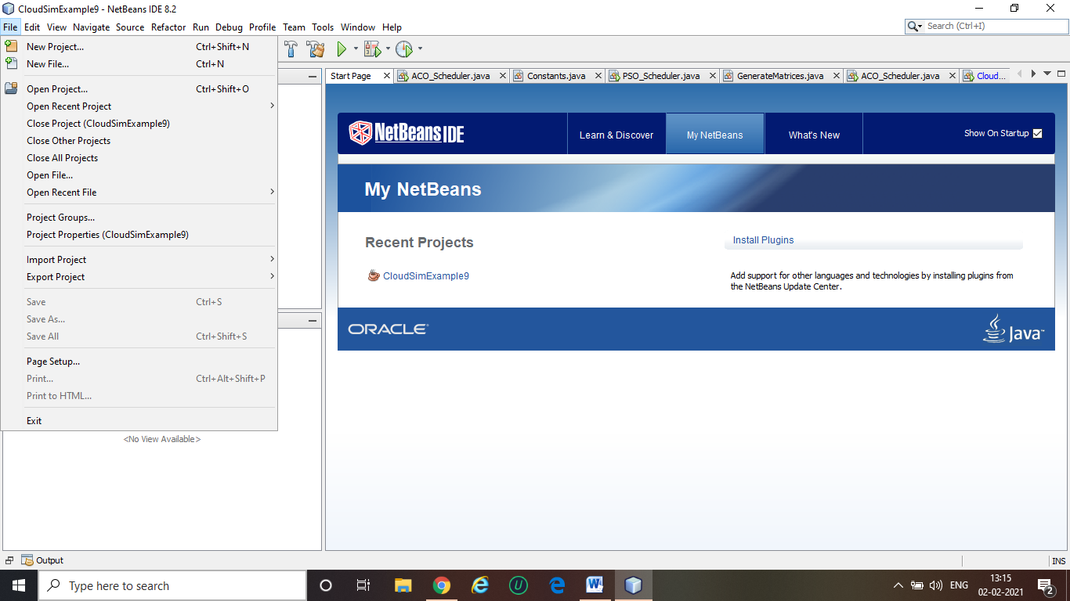

Step 4. Go to that location where Cloudsim- round robin folder download and add this folder and select open project

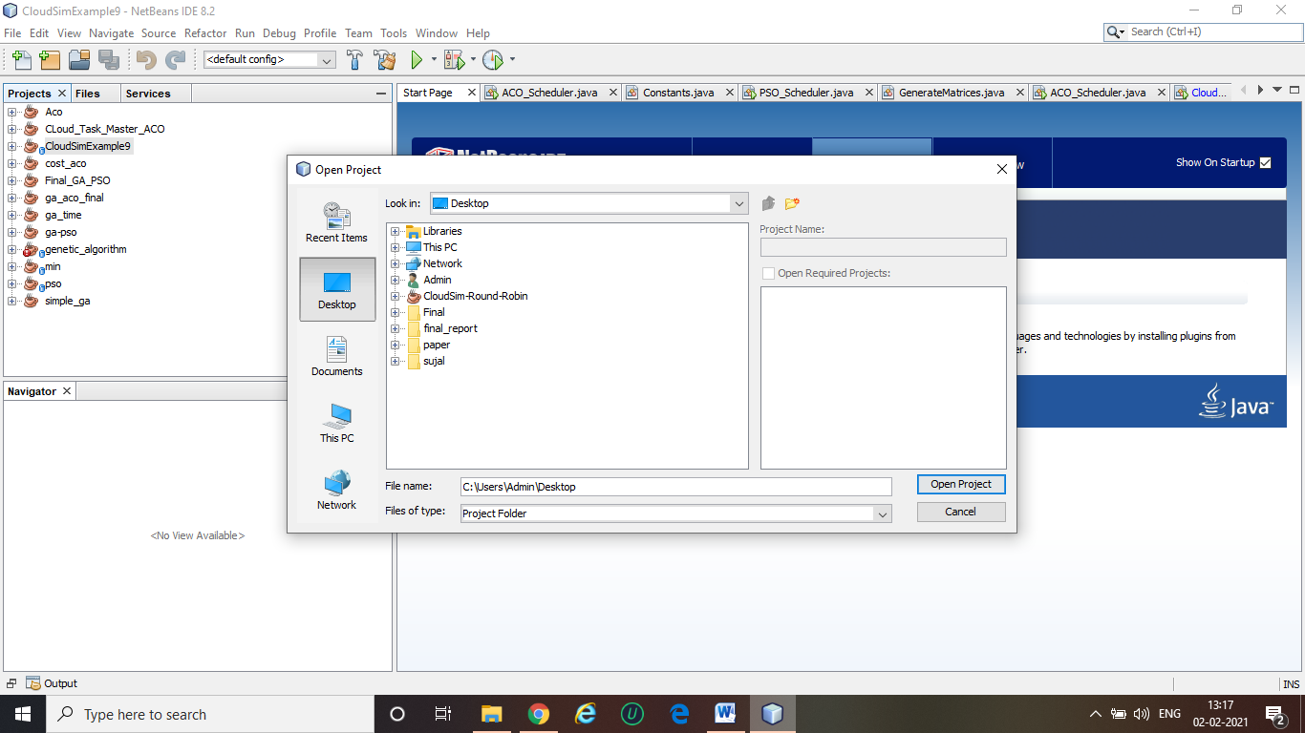

Step 5 project is successfully now runs the cloudsimexample9.java file main file of this project

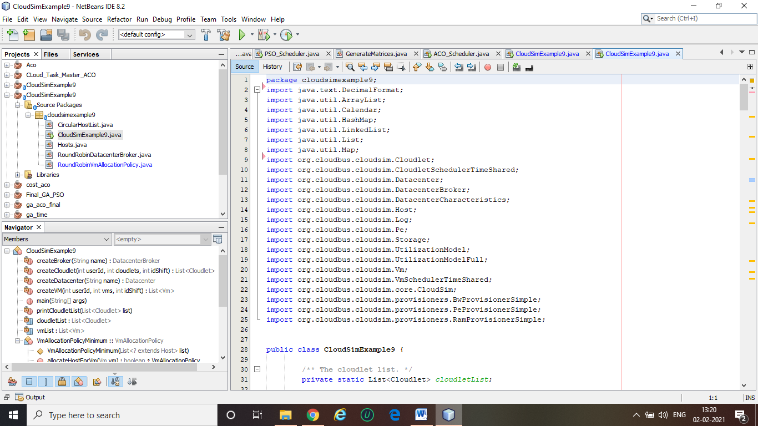

Step 6 successfully runs and output comes

